🔷 Lab Title
Send Email on Blob Upload using Azure Function + Logic App

🎯 Objective
When a file is uploaded to Azure Blob Storage:
- An Azure Function is triggered
- Function sends event/data to Logic App
- Logic App sends an email notification

🧱 Architecture Flow
Blob Upload → Azure Function Trigger → HTTP Call → Logic App → Email Sent

🛠️ Services Used
- Azure Storage Account
- Azure Blob Storage
- Azure Functions
- Azure Logic Apps
- Office 365 Outlook Connector (or Gmail)

🧪 PART 1: Create Storage Account & Container
Steps:
- Go to Azure Portal → Create Resource
- Select Storage Account
- Fill:
  - Name: storagelabdemo123
  - Region: Same for all services
- After creation → Go to Containers
- Create container:
  - Name: uploads
  - Access level: Private

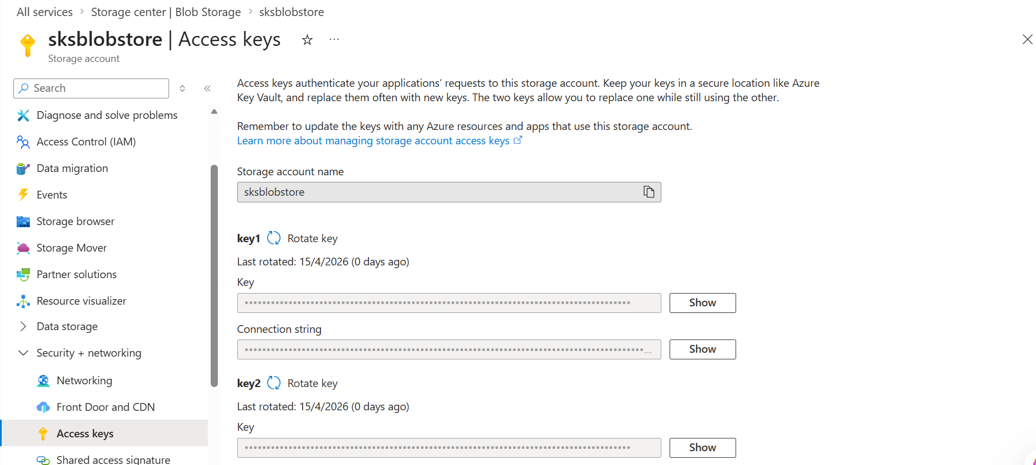

🧪 PART 2: Create Azure Function (Blob Trigger)
Create Function App:
- Create → Function App
- Runtime: .NET 6/8 (Isolated or In-Process)
- Hosting: Consumption plan

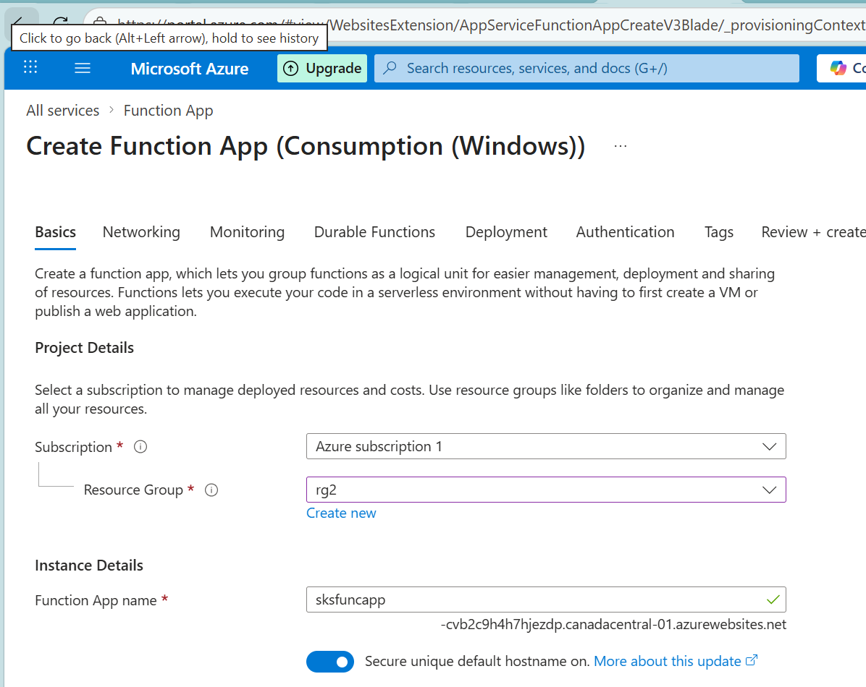

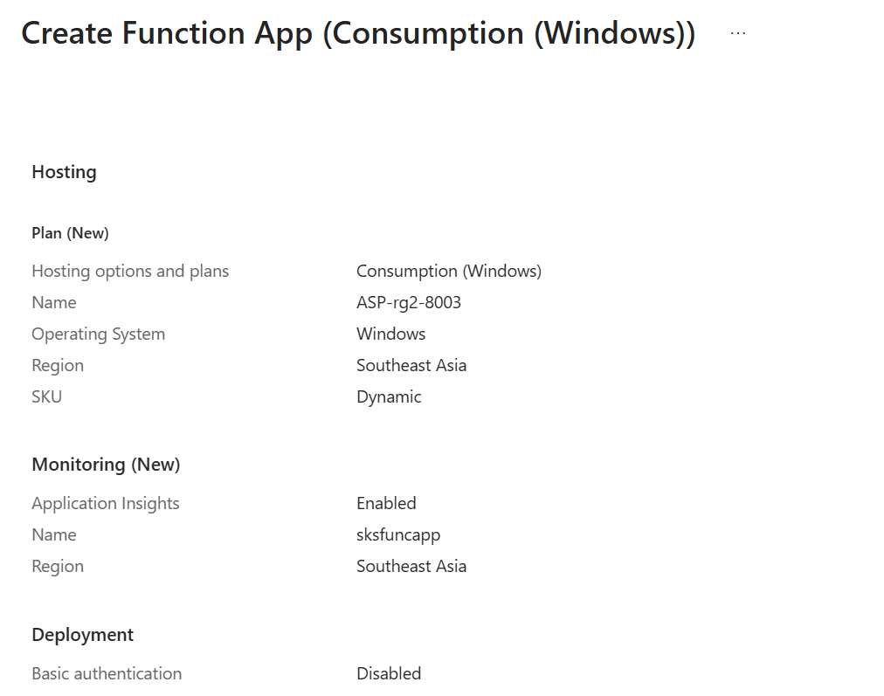

Region same for RG and storage account – SoutheastAsia

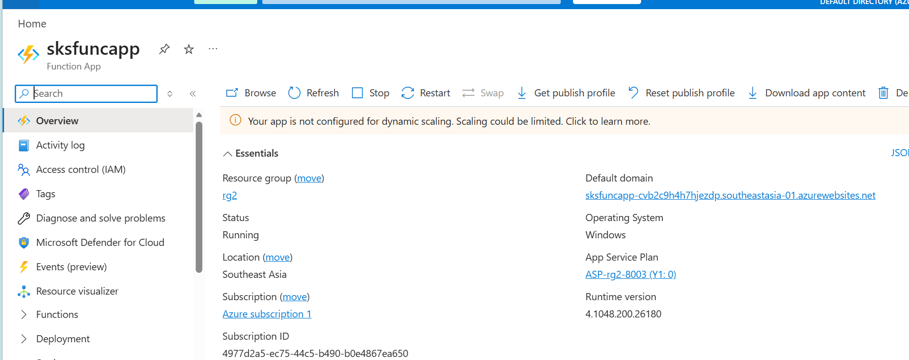

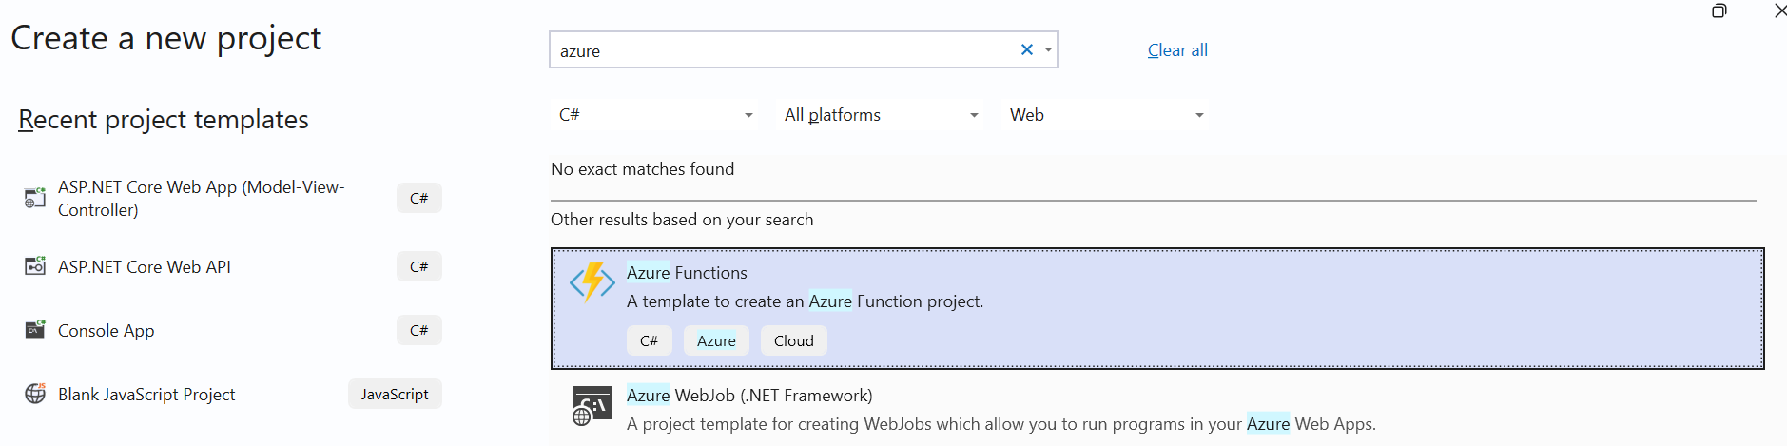

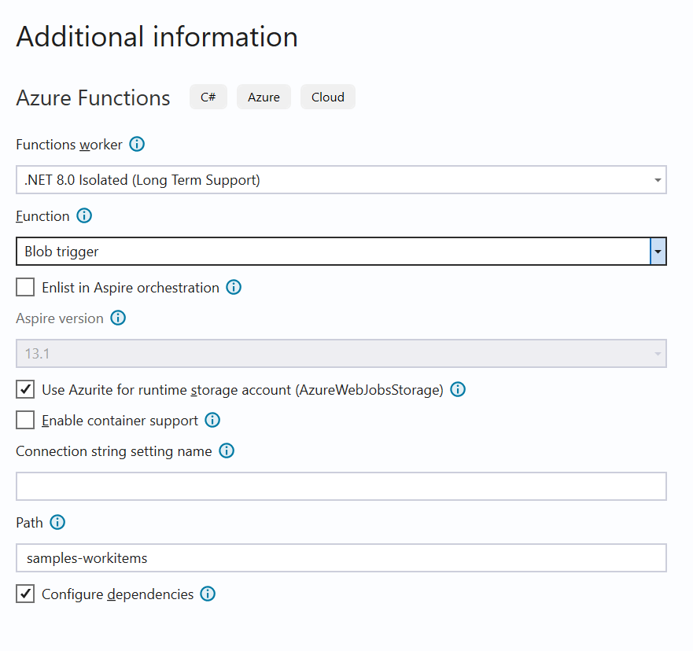
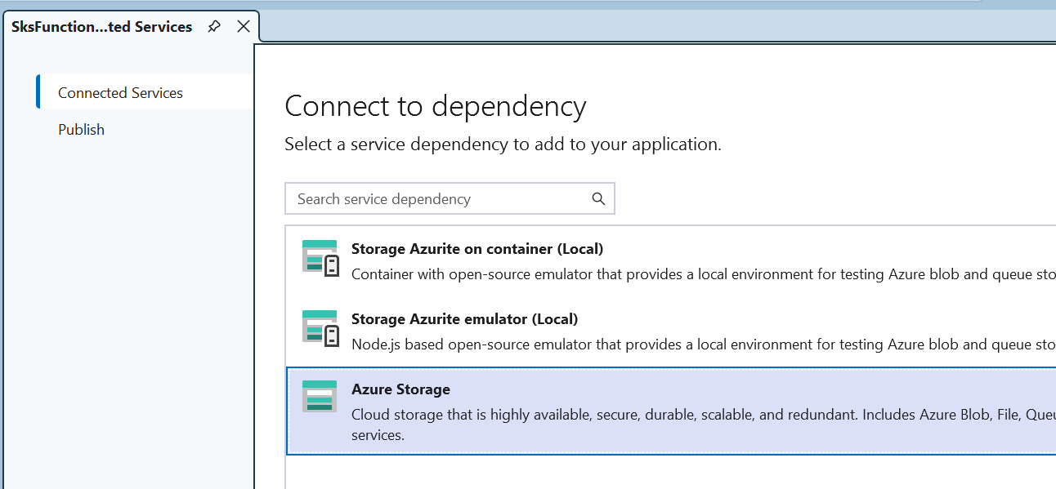
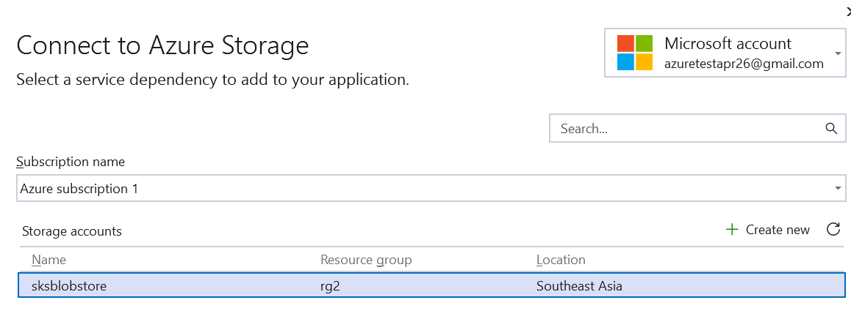

Add Function (Blob Trigger)
Function Name:
BlobUploadFunction
Code:
using System.IO;
using System.Net.Http;
using System.Text;
using System.Threading.Tasks;
using Microsoft.Azure.Functions.Worker;
using Microsoft.Extensions.Logging;
public class BlobUploadFunction
{
private readonly ILogger _logger;
public BlobUploadFunction(ILoggerFactory loggerFactory)
{
_logger = loggerFactory.CreateLogger<BlobUploadFunction>();
}
[Function("BlobUploadFunction")]
public async Task Run(
[BlobTrigger("uploads/{name}", Connection = "AzureWebJobsStorage")] Stream blob,
string name)
{
_logger.LogInformation($"Blob detected: {name}");
var logicAppUrl = "<PASTE_LOGIC_APP_HTTP_URL>";
using var client = new HttpClient();
var json = $"{{ \"fileName\": \"{name}\" }}";
var content = new StringContent(json, Encoding.UTF8, "application/json");
await client.PostAsync(logicAppUrl, content);
}
}

Publish to Azure.

🧪 PART 3: Create Logic App (Email Sender)
Steps:
- Create → Logic App (Consumption)
- Open Designer

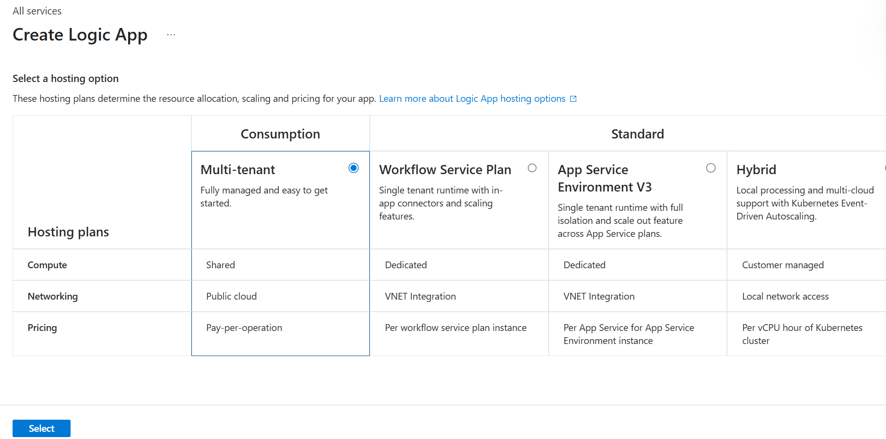

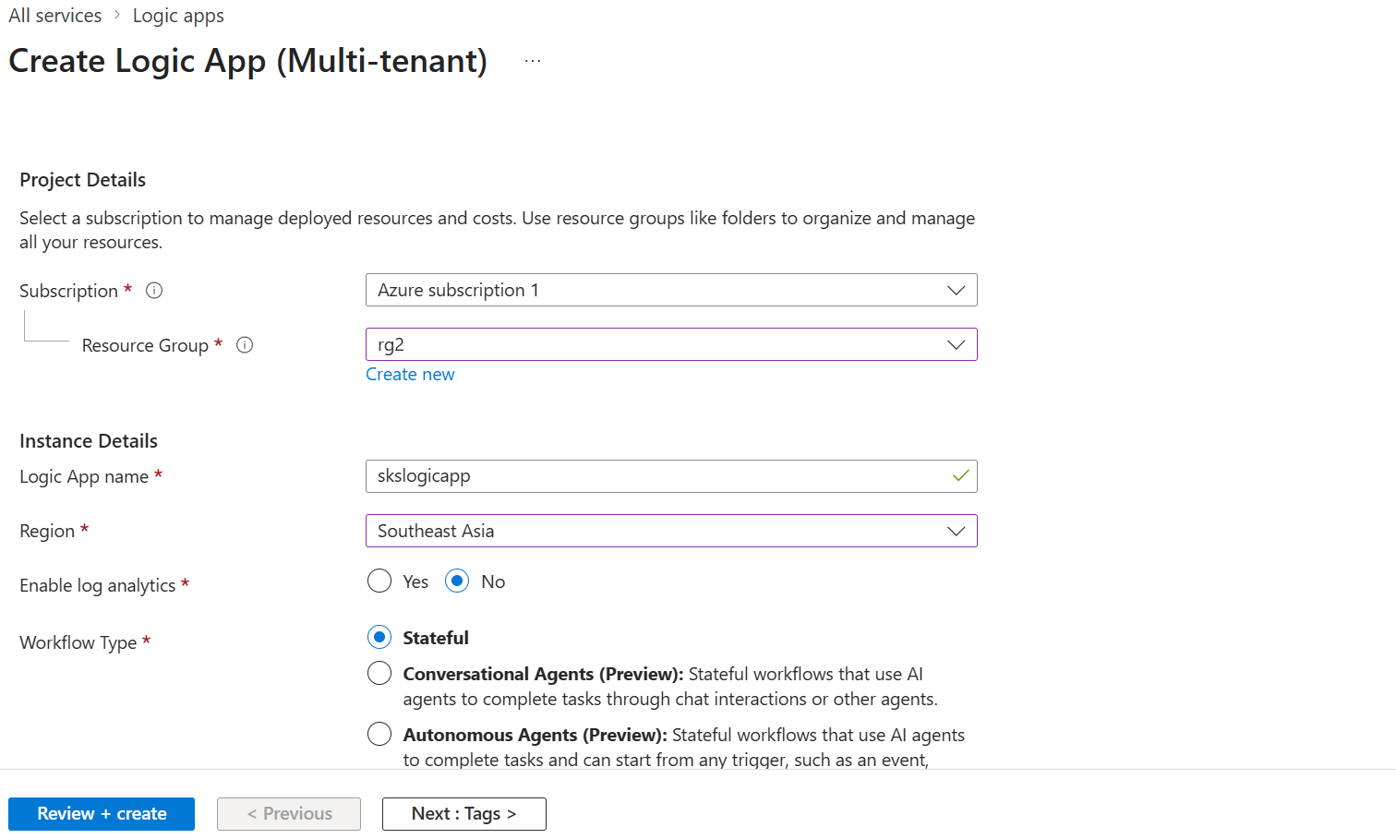

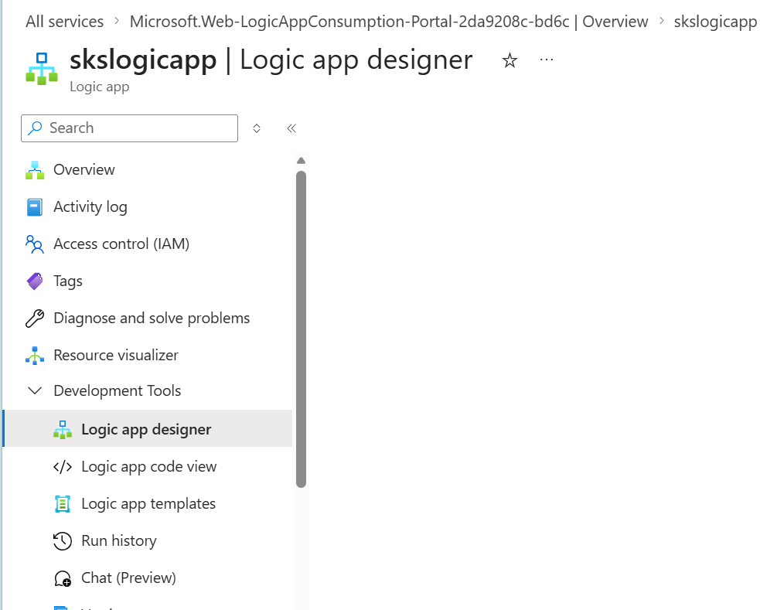

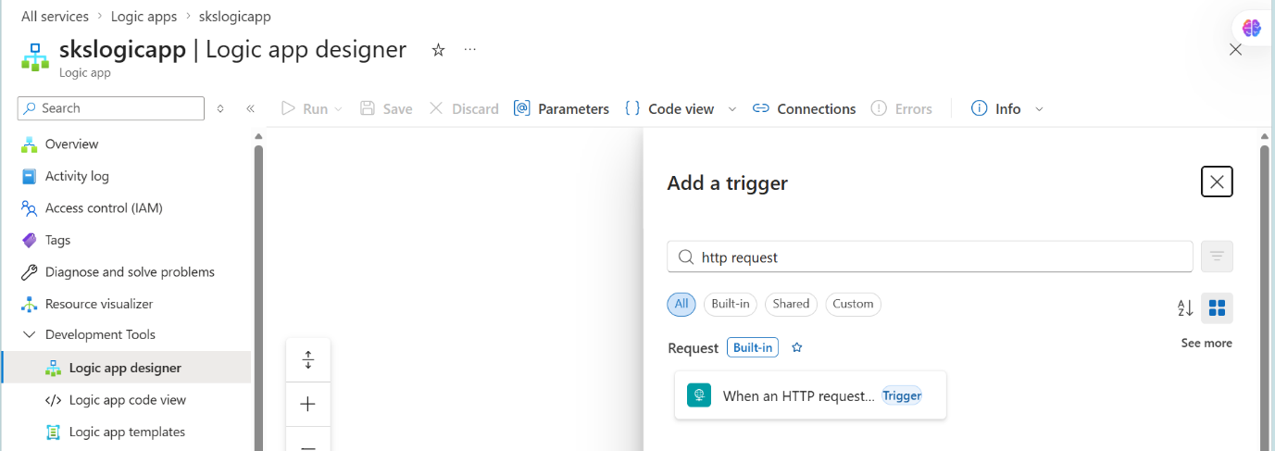

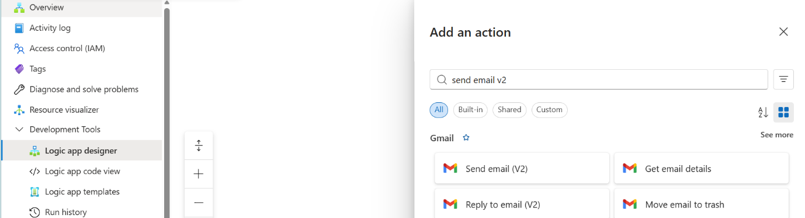

Sign in to gmail

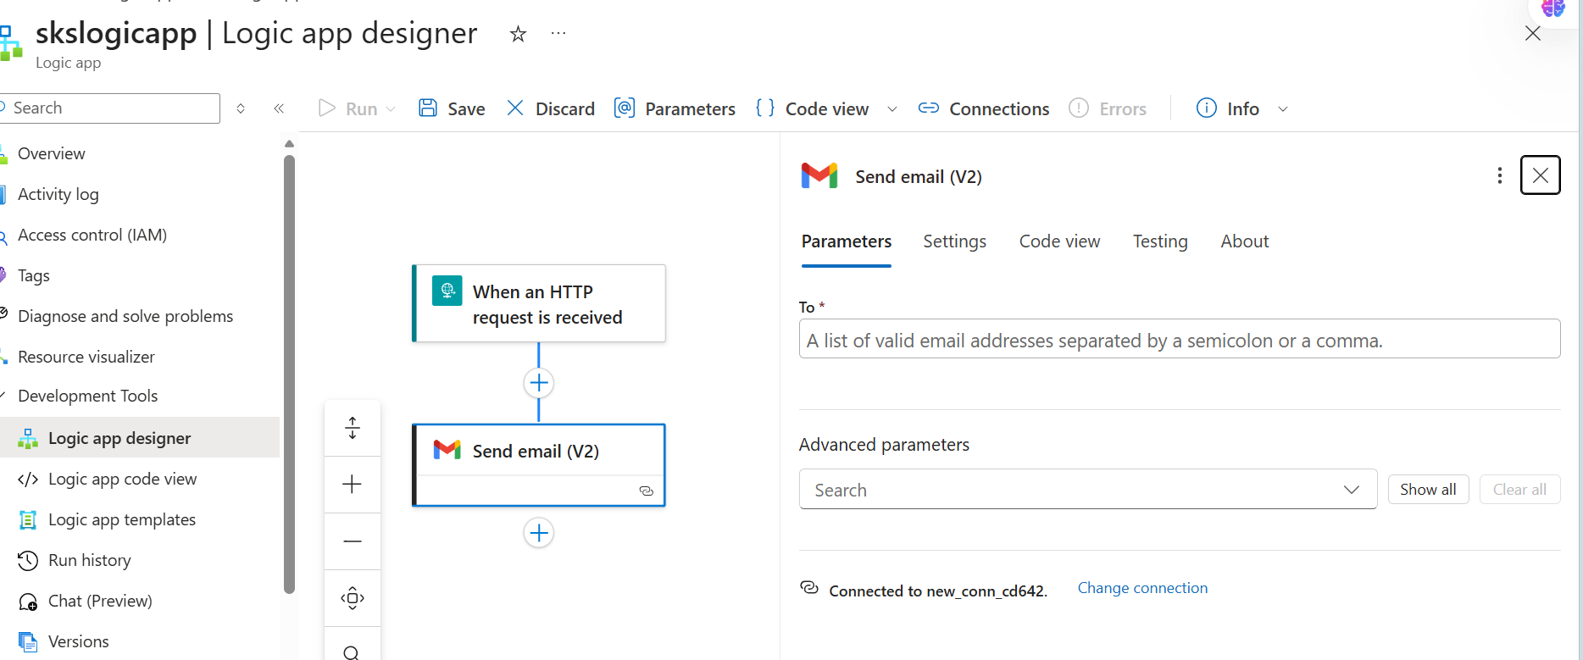

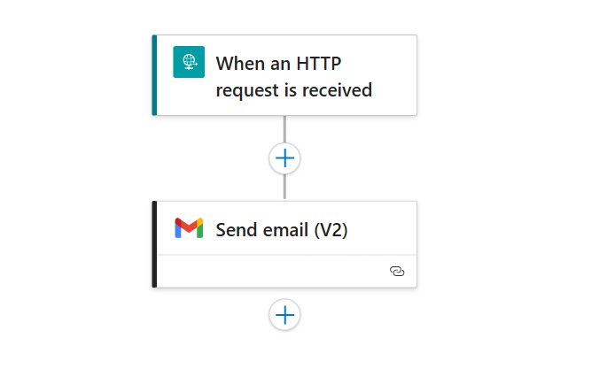

Select advanced parameters – Subject and Body

Step 1: Trigger
- Choose: When HTTP request is received
Sample JSON schema:
{
"type": "object",
"properties": {
"fileName": {
"type": "string"
}
}
}

Step 2: Add Action → Send Email
Choose:
- Outlook OR Gmail connector
Example (Outlook):
- Action: Send an email (V2)
Fill:
- To: your email
- Subject:
New File Uploaded: @{triggerBody()?['fileName']}
- Body:
A new file has been uploaded to Blob Storage.
File Name: @{triggerBody()?['fileName']}

Step 3: Save Logic App
👉 Copy the HTTP POST URL
👉 Paste into Function code

public class BlobUploadFunction
{
private readonly ILogger _logger;

public BlobUploadFunction(ILoggerFactory loggerFactory)
{
_logger = loggerFactory.CreateLogger<BlobUploadFunction>();
}

[Function("BlobUploadFunction")]
public async Task Run(
[BlobTrigger("uploads/{name}", Connection = "AzureWebJobsStorage")] Stream blob,
string name)
{
_logger.LogInformation($"Blob detected: {name}");

var logicAppUrl = "https://prod-48.southeastasia.logic.azure.com:443/workflows/d490c1d9f3f74c8a8cdf3ebf0fed30d8/triggers/When_an_HTTP_request_is_received/paths/invoke?api-version=2016-10-01&sp=%2Ftriggers%2FWhen_an_HTTP_request_is_received%2Frun&sv=1.0&sig=YEdVtamyQL6XkTaYqVZ0FMzUPs73bEkxB4NHdgPvJHA";

using var client = new HttpClient();

var json = $"{{ \"fileName\": \"{name}\" }}";

var content = new StringContent(json, Encoding.UTF8, "application/json");

await client.PostAsync(logicAppUrl, content);
}
}

https://prod-48.southeastasia.logic.azure.com:443/workflows/d490c1d9f3f74c8a8cdf3ebf0fed30d8/triggers/When_an_HTTP_request_is_received/paths/invoke?api-version=2016-10-01&sp=%2Ftriggers%2FWhen_an_HTTP_request_is_received%2Frun&sv=1.0&sig=YEdVtamyQL6XkTaYqVZ0FMzUPs73bEkxB4NHdgPvJHA

🧪 PART 4: Test the Flow
Upload File:
- Go to Storage Account → Container uploads
- Click Upload
- Select any file

Expected Result:
- Function triggers automatically
- Logic App is called
- Email is received ✅

Testing

Logic App -> Run with payload
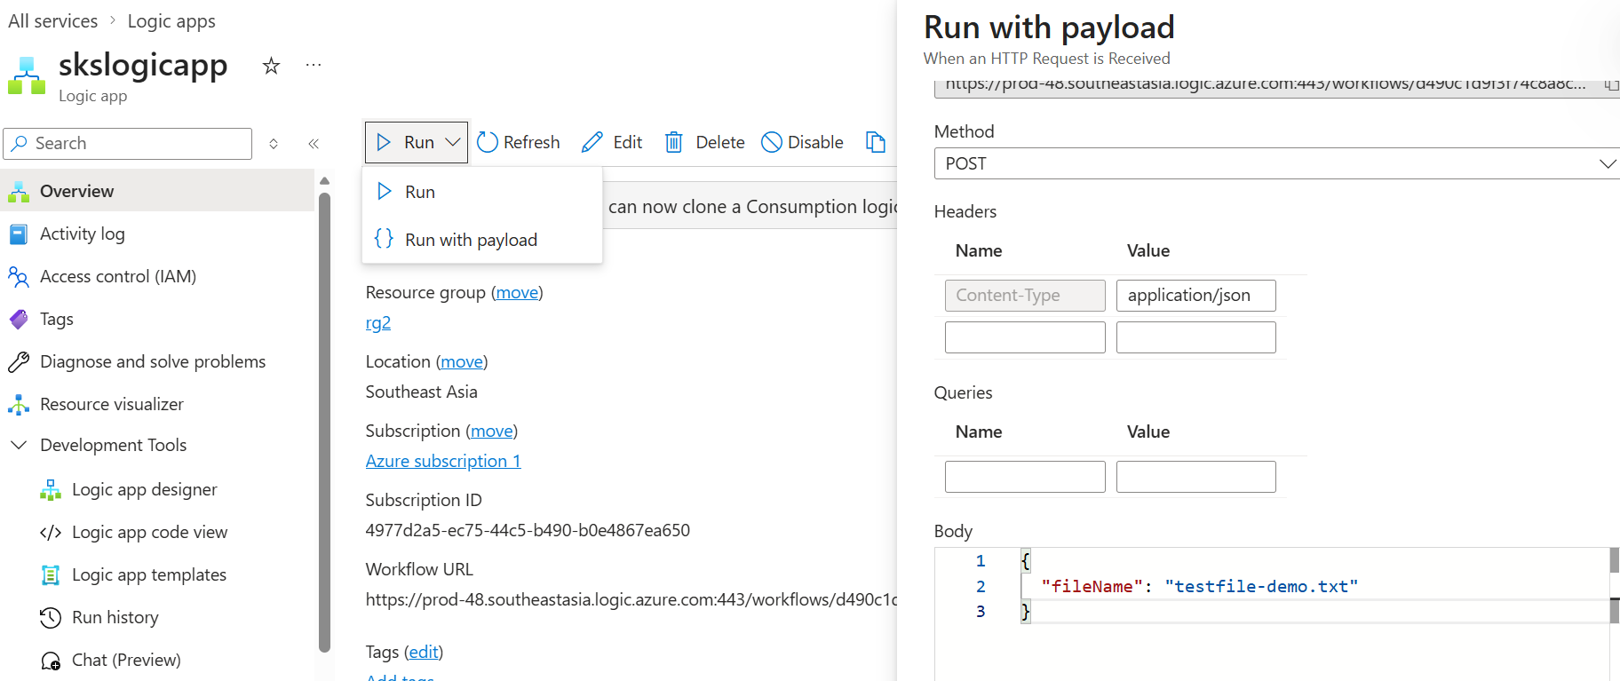

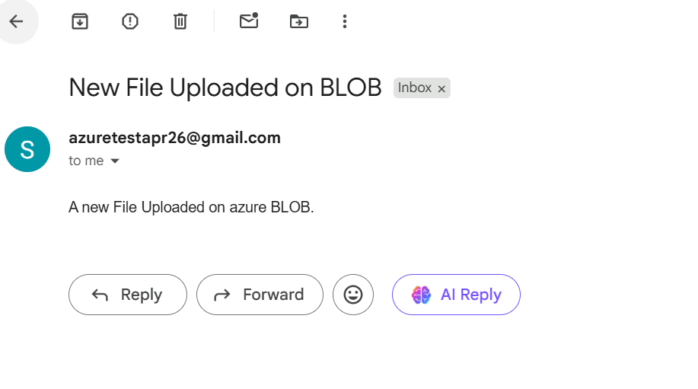

Troubleshooting –
🔴 1. Absolute First Check — Storage Binding
Go to:
👉 Azure Functions → Your Function App → Settings -> Environment variables
✔ Must have:
AzureWebJobsStorage (add connectionString as value)
👉 If this is missing or incorrect → trigger will NEVER fire

Insights

🔷 1. Can Azure Function alone send email?
👉 Yes — absolutely.
Using:
- SMTP (e.g., Gmail)
- SendGrid API
- Microsoft Graph API
Inside Azure Functions you can write:
// Example: Send email via SMTP / API
✅ When Function-only makes sense
- You need custom logic
- Complex transformations
- Conditional workflows (if/else, loops)
- Integration with code-heavy systems (.NET logic, DB calls)
❌ Limitations
- You must handle:
  - Retry logic
  - Failures
  - Monitoring
  - Secrets management
- Email handling becomes code responsibility
👉 In short:
Function = flexible but more engineering effort

🔷 2. Can Logic App alone send email on blob upload?
👉 Yes — even simpler.
Using Azure Logic Apps:
Trigger:
- “When a blob is added or modified”
Action:
- “Send Email” (Office 365 / Outlook / Gmail)

✅ When Logic App-only is ideal
- No coding required
- Fast to build demo / workflow
- Built-in connectors:
  - Outlook
  - Gmail
  - Teams
  - SharePoint
❌ Limitations
- Limited customization
- Complex logic becomes messy
- Not ideal for heavy processing
👉 In short:
Logic App = low-code, fast, but less flexible

🔷 3. Then WHY combine Function + Logic App?
This is the real architectural value.
Pattern:
Blob Upload → Function → Logic App → Email

🎯 Why this is preferred in real systems
✔ Separation of concerns
- Function → processing logic
- Logic App → workflow/orchestration

✔ Better maintainability
- Change email workflow → no code change
- Change logic → no workflow redesign

✔ Enterprise-grade reliability
Logic Apps provide:
- Built-in retries
- Visual tracking
- Failure handling

✔ Reusability
One Logic App can serve:
- multiple functions
- multiple systems

✔ Non-developers can modify workflows
Business teams can edit Logic App without touching code

🔷 Decision Matrix (Very Practical)
Scenario | Best Choice
Simple email on upload | Logic App only
Complex processing + email | Function only
Enterprise scalable workflow | Function + Logic App ✅

🔷 Your Demo Choice (Why it was perfect)
You demonstrated:
✔ Event-driven architecture
✔ Serverless compute
✔ Workflow automation
That’s exactly how modern Azure solutions are built.

🔥 One-line Summary
- Function = brain (logic)
- Logic App = workflow engine (actions & integrations)

